33.9: a) Let the light initially be in the material with refractive index n_{a} and let the third and final slab have refractive index n_{b} Let the middle slab have refractive index n₁
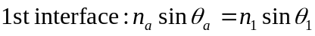
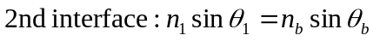
b) For N slabs, where the first slab has refractive index n_{a} and the final slab has
incidence in the first slab and the indicies of the first and last slabs.

